Hire Up BBO Supervisor Portal Instructions
hireup.bbo.bullhornstaffing.com

Login Credentials

When a new placement is created, supervisors are emailed login credentials for the web portal to review and approve their employees’ timecards online each week. Hire Up’s weekly pay period runs Monday – Sunday. Employee timecard submissions are due Mondays by noon for hours worked the previous week so that supervisors have adequate time to approve timecards before the Tuesday at 11 a.m. cutoff time.

Topics
- How Do I Reset My Manager Password?
- How Do I View Employee Details?
- How Do I View Timesheet Details?
- How Do I Assign A Secondary Manager?
- How Do I Remove A Secondary Manager?
- How To Approve Timesheets
- How Do I View and Approve Timesheets Via Email?

How Do I Reset My Manager Password?

From the login screen, Select "Forgot Password"

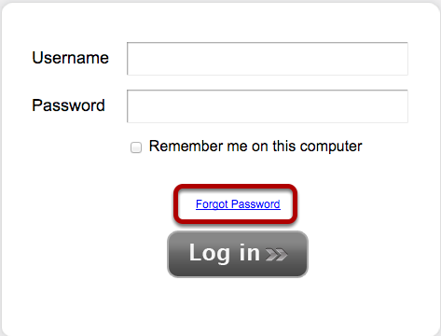

Type your username and Select "Send Email Reminder"
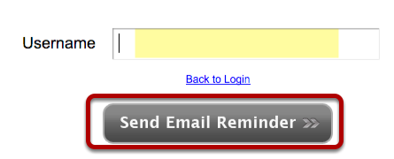
An email will be sent to you with a new password

Select Back to Login
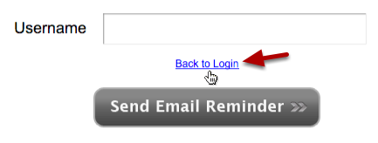

Enter your username and NEW password

How Do I View Employee Details?

Log in the Application, Select the Employees Tab
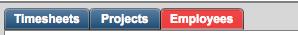

Select Employee
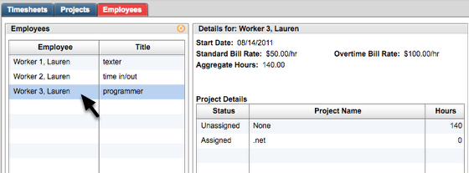

All available details will appear to the right.

How Do I View Timesheet Details?

Select the Timesheet status
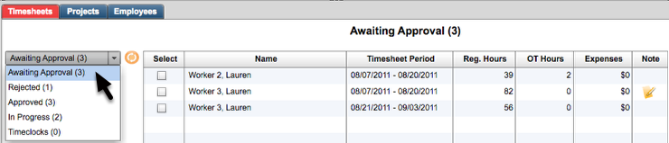

Select Timesheet and View Details
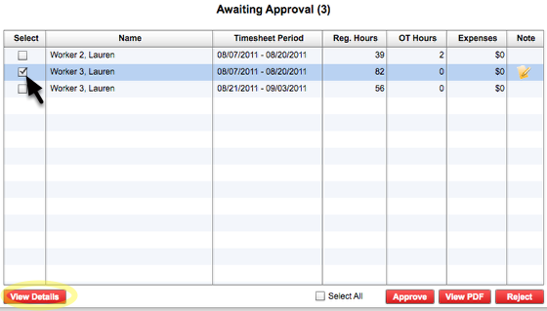

View Time Block Details
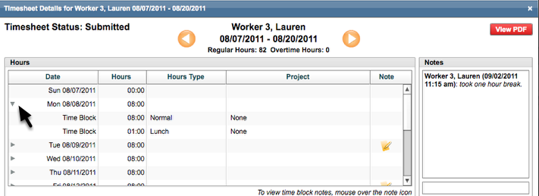
On each day with hours, click the row to expand in order to view the individual time block.

View Time Block Notes
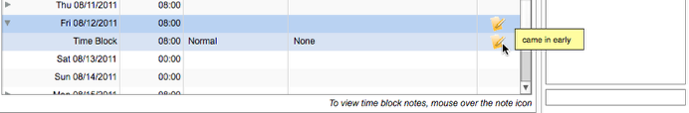
If there are any notes for the time block simply hover the mouse over the note icon to view the details of the note.

View next Timesheet Details
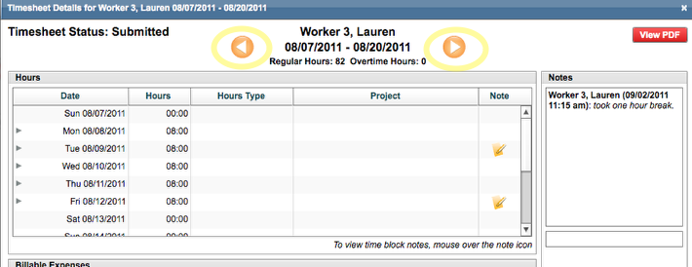

You can scroll through all timesheet from this popup by simply clicking the arrow buttons in either direction.

Approve or Reject
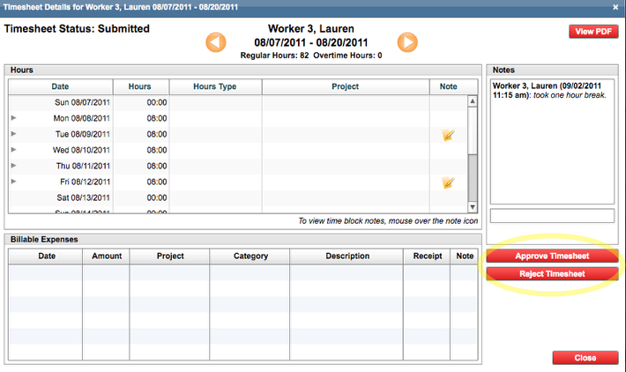
To approve or reject timesheets, simply click the respective button for each timesheet.

How Do I Assign a Secondary Manager?
Secondary approval will allow for either you or the Secondary Manager to approve timesheets for your entire group of assigned employees. The Secondary Manager will receive all of the same system email notifications as you do.

Log into the Application, Select the Employees Tab

Use the drop down to Select a Secondary Manager
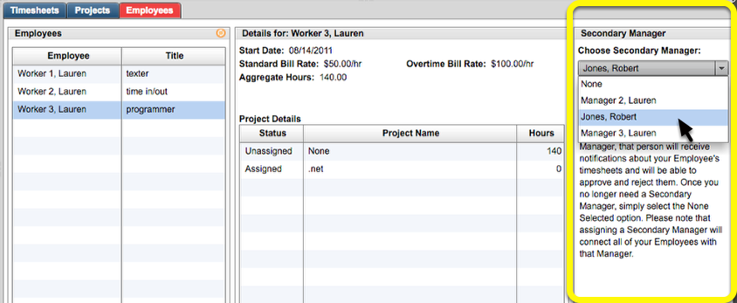

How Do I Remove a Secondary Manager?

Log into the Application, Select the Employees Tab

To Remove a Secondary Manager, Select "None"
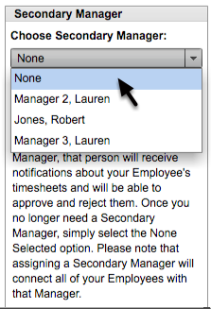
By selecting None, the previous Secondary Manager will no longer be able to view or receive notifications for your assigned employees.

How to Approve Timesheets

Log into the Application using your username and password
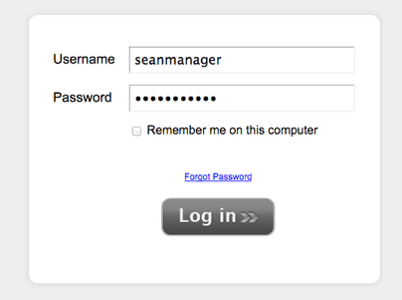

Once logged in, you will land on the "Awaiting Approval" page of the application
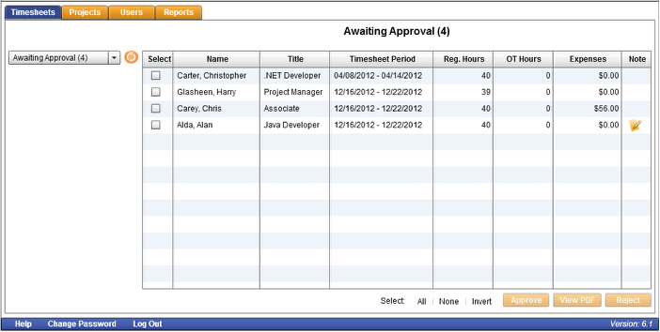

You can either Approve / Reject Timesheets from this page or View the Details for each Timesheet
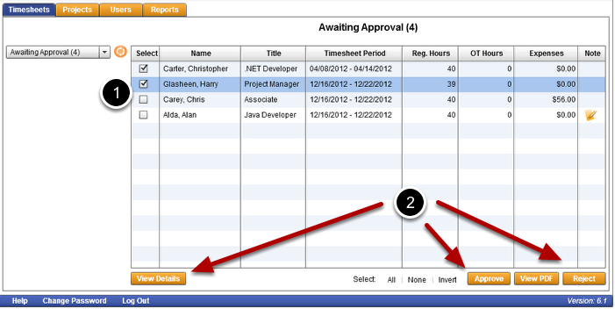
To do so, click the checkboxes next to one or more of the Timesheets (1). The "View Details", "Approve" and "Reject" buttons will become enabled (2). Click on the "Approve " button if you wish to approve the specific Timesheets that are selected.

How Do I View and Approve Timesheets via Email?

Once all of your employees have submitted their time, you'll receive an Approval Email:
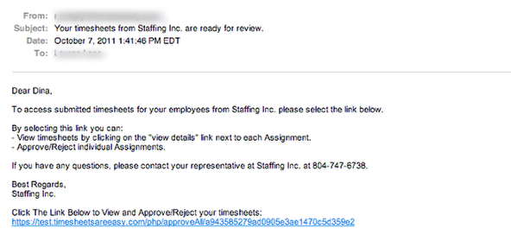
Select View Details to open the Timesheet as a pdf

Select the link to access your timesheets that are awaiting approval.
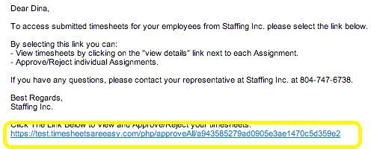

All of the timesheets will automatically become selected. Change your selection as needed.
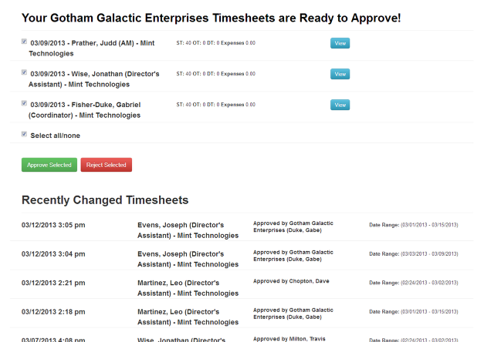

Selecting View Details will open a pdf of that timesheet.
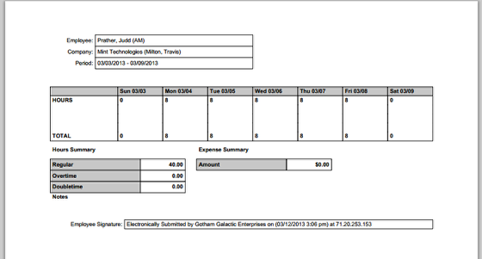

Selecting Approve or Reject will only affect the timesheets you have selected.
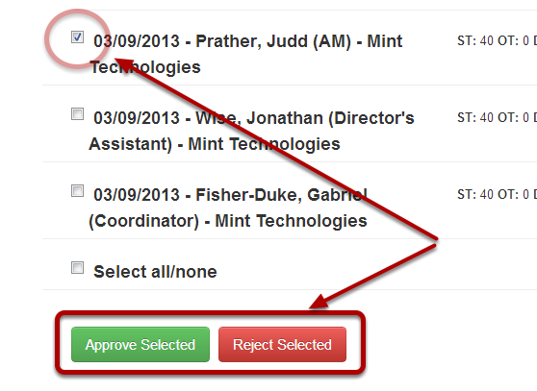

The timesheets will no longer be seen once they are Approved.
